- Place the security certificate in the IVMS Sever \ cert folder. (If you do not have this folder, please create it yourself)
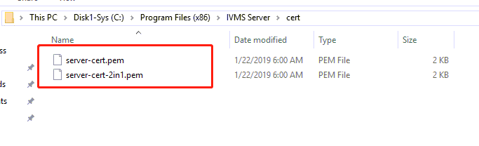

- Modify the config file…\IVMS Sever\IVMSSSLServer.ini：
For example: IVMSSSLServer.ini

name：Server name+ssl
Count：the number of gateway server and login server
CrtFile：the security certificate
SSL_Enbled: 1 means enable
listen：ssl port
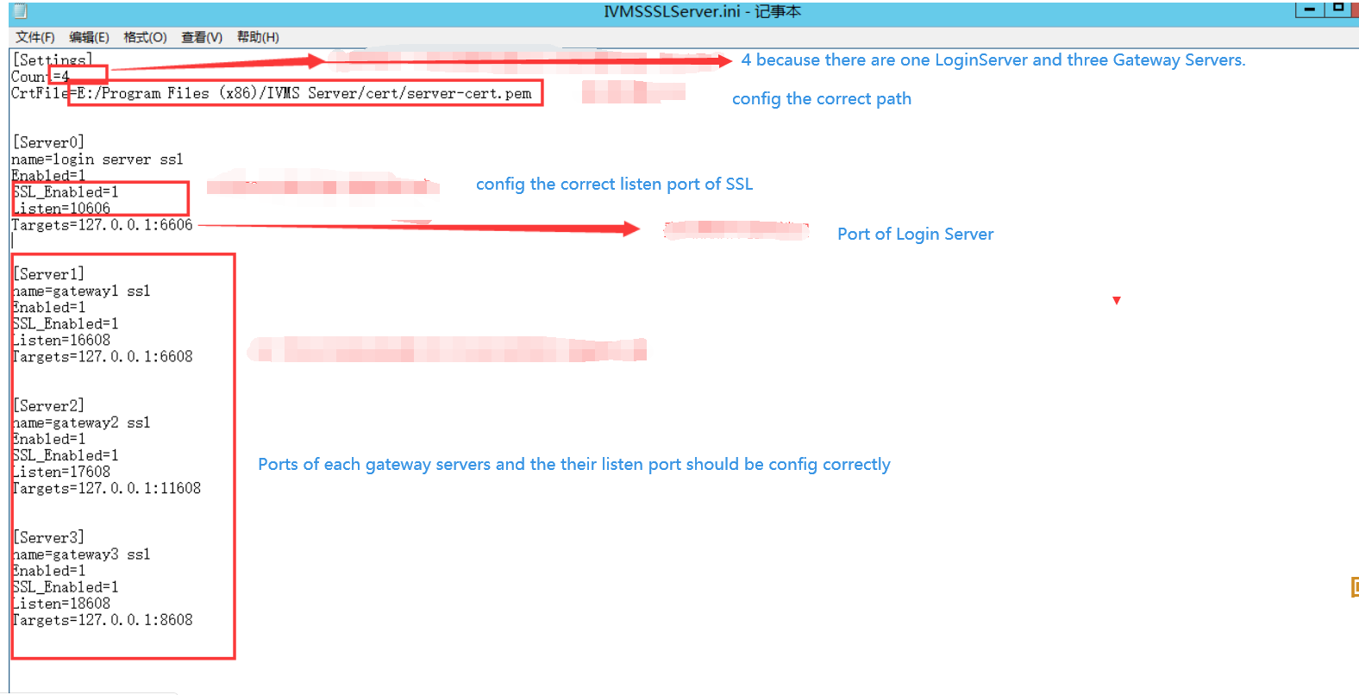
- Login web with admin account，modify gateway server configuration（the port shouldbethe same as the config file of IVMSSSLServer.ini，click the support ssl service）
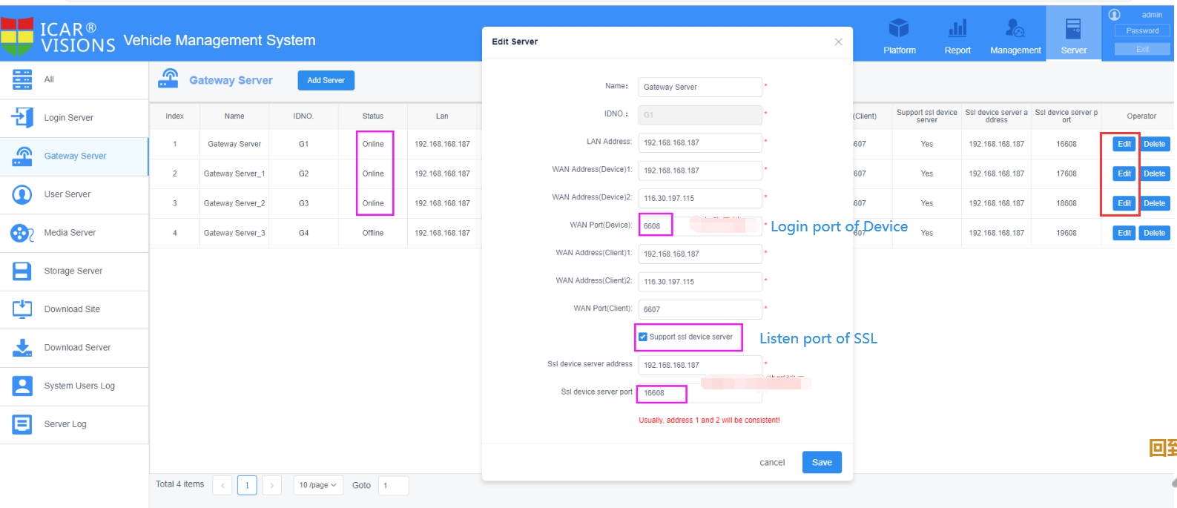
- Restart the IVMS Server
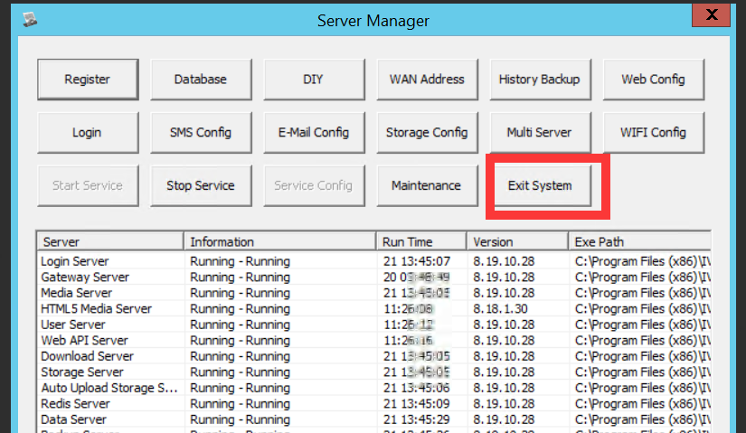
- Check if MDVR could access to IVMS Server with SSL. 